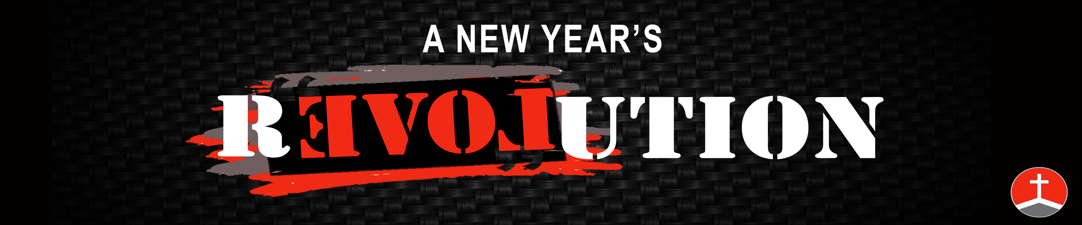
Bro. Matt

When Opposition Shows Up
Nehemiah 4:1-23

When you begin the journey into freedom, you will find that not everyone wants you to stay there.

1. When Your Revolution Happens Opposition Shows Up

How do opponents respond?

Satan often uses the anger of others to try to squelch the newfound joy and zeal of a new believer.

Satan will use ridicule and Sarcasm to cause disciples to feel dismayed and disarmed in any situation.

Satan will use intimidation to cause you to back down even before any action has happened.

Angry-

Sarcasm-

Intimidation-

Discouragement and Exhaustion-

Satan knows that the halfway point in any work is the most effective time to strike.

2. When Opposition Shows Up Let God Show Out

Pray About it-

Give it All You Got -

Keep Enemy In Focus-

Focus On The One Who Knows The Situation-

What will you do when the opposition shows up?
Bro. Matt

When Opposition Shows Up
Nehemiah 4:1-23

When you begin the journey into freedom, you will find that not everyone wants you to stay there.

1. When Your Revolution Happens Opposition Shows Up

How do opponents respond?

Satan often uses the anger of others to try to squelch the newfound joy and zeal of a new believer.

Satan will use ridicule and Sarcasm to cause disciples to feel dismayed and disarmed in any situation.

Satan will use intimidation to cause you to back down even before any action has happened.

Angry-

Sarcasm-

Intimidation-

Discouragement and Exhaustion-

Satan knows that the halfway point in any work is the most effective time to strike.

2. When Opposition Shows Up Let God Show Out

Pray About it-

Give it All You Got -

Keep Enemy In Focus-

Focus On The One Who Knows The Situation-

What will you do when the opposition shows up?

